**C:\Program Files\Android\Android Studio\bin**

**Start Studio64**

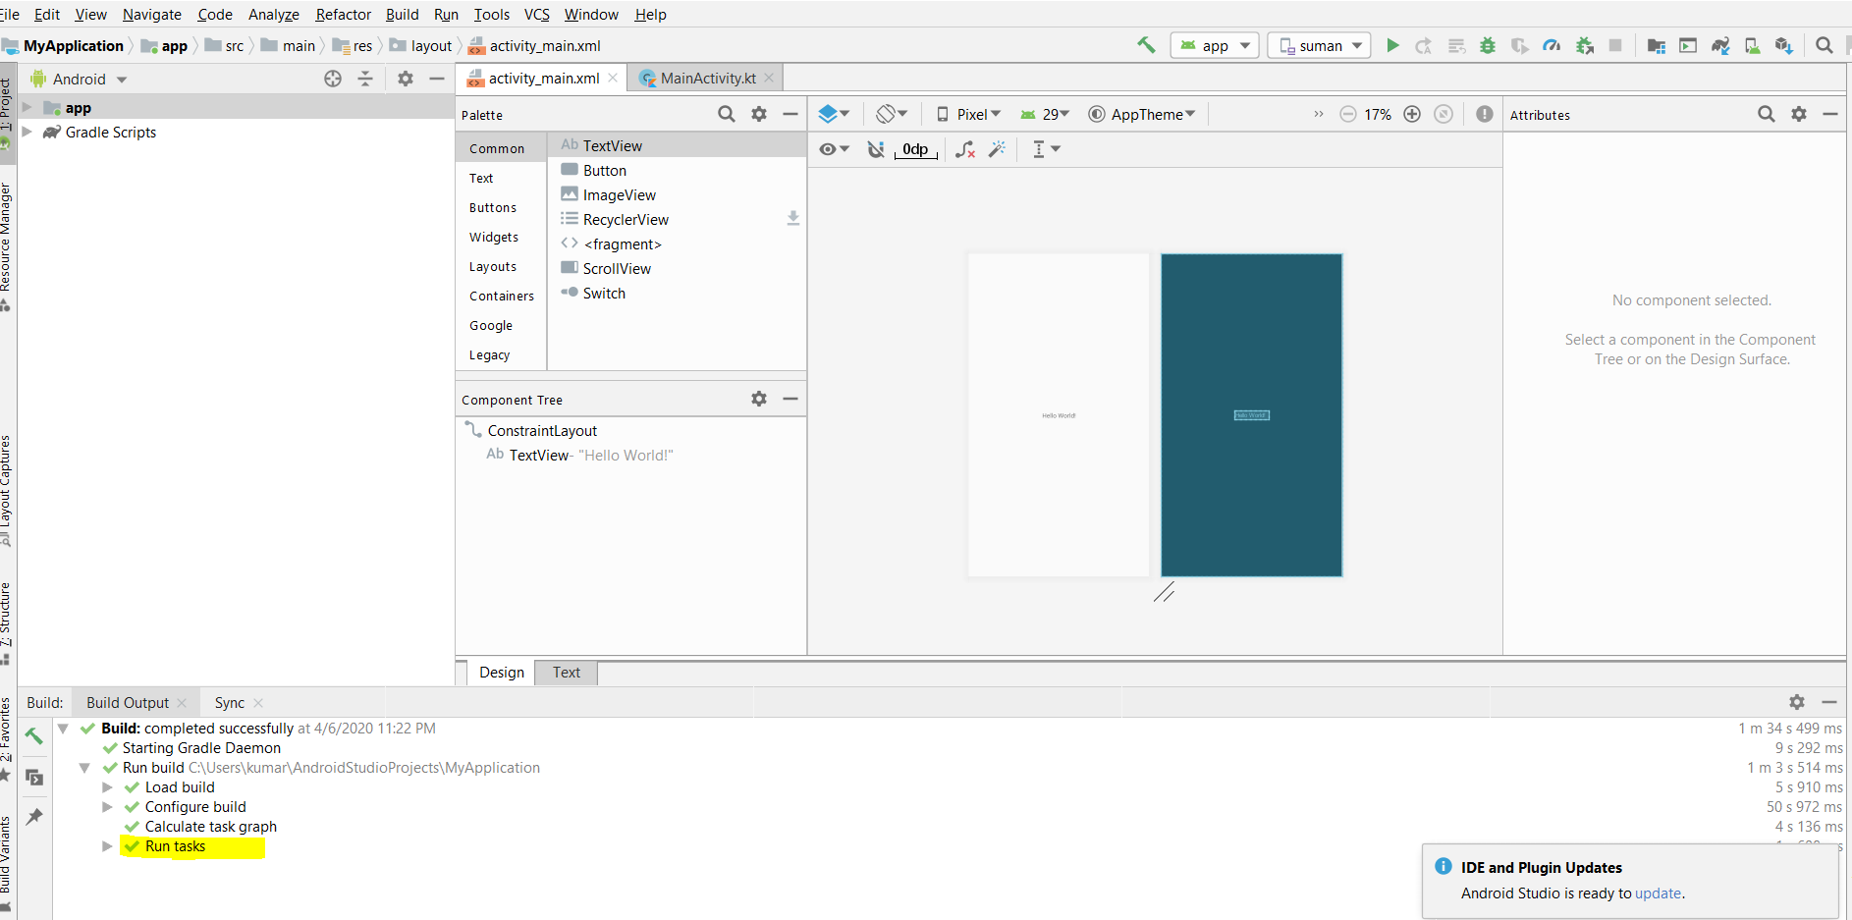

**Start the Emulator**

**Tools -> Avd Manager –Launch Emulator**

